Contact: FOR IMMEDIATE RELEASE
Jonathan Svilar 3-1-2018
Phone: 510-597-3527
marketing@companion-group.com

The Companion Group Attends The 2018 International Home and Housewares Show

BERKELEY, CA – The Companion Group is attending the International Home and Housewares Show in Chicago on March 10 -13th. We will be back at booth #1971 featuring seven brands this year: Charcoal Companion® , Patio Companion®, JFish Collection, McCormick® Grill Mates®, Not In My Backyard™, Pizzacraft®, and Steven Raichlen’s Best of Barbecue™.

The booth will highlight some of our newest brands while showcasing our focus on trending colors in the market, unique custom designs, and inspired products for the home and backyard.

“Retailers can see that while we are honing in on individual brand design, popular trends, and customer needs, we are also expanding the breadth of our products. Our unique ability to bring both craftsmanship and product diversity to over seven lines makes us stand out as a great partner and the go-to for custom design as proven by our strong partnerships with brands like McCormick, William Sonoma, Sur La Table, Crate and Barrel and many more!” Says COO Leah Belzer-Adams.

We will be bringing a full line of products from our recent partnership with McCormick® Grill Mates®, a line of must-have grilling accessories that put flavor first – from burger presses to marinade injectors. Attendees can stop by for an exciting McCormick® product giveaway in honor of this great partnership.

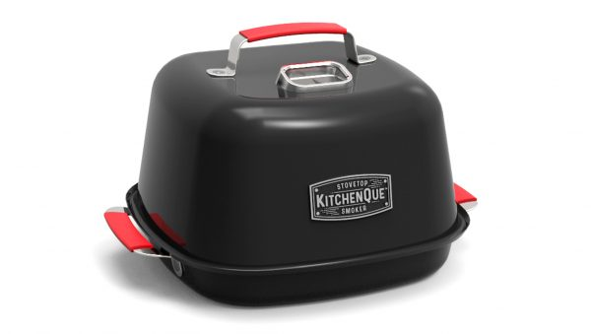
New products like the KitchenQue™ from Charcoal Companion® will be shown as our recent innovation in indoor cooking accessories. The KitchenQue™ Stovetop Smoker gives you the opportunity to smoke foods indoors as you would in a conventional smoker.
Alongside the KitchenQue™ will be an in-depth look at our new line of safe grill cleaning tools. A popular line that puts safety first and addresses bbq hazards with safer products for the grill.

We will be showing for the first time new products from our brand’s Patio Companion® and JFish Collection that bring a heightened level of design to indoor and outdoor spaces. Those who stop by can expect to see the amazing diversity of custom work The Companion Group does with candles and local artists.

Returning will be our line from Not In My Backyard™ with safe and effective bug repellent options that make the outdoor experience family friendly and comfortable. These products will exemplify a shift in the market to more eco-friendly products that put the consumer first.

Visit our booth for the full assortment of products that bring thoughtful design to the home and backyard.

# # #

Founded in the Bay Area in 1984, The Companion Group develops and markets an array of brands in the outdoor and indoor living categories, including Charcoal Companion®, Steven Raichlen Best of Barbecue™, pizzacraft®, and Not In My Backyard™. In 2014 The Companion Group evolved into an employee stock ownership plan (ESOP) and continues to thrive on a commitment to creative and innovative design, unique licensing-partnerships, superior communication and service, and well-developed retail solutions for an ever-changing marketplace. For more information, visit www.companion-group.com.

