Contact: FOR IMMEDIATE RELEASE
Jonathan Svilar 8-21-2017
Phone: 510-597-3527
marketing@companion-group.com

The Companion Group and McCormick® Grill Mates® Launch Line of 20+ Essential Grilling Accessories

BERKELEY, CA – The Companion Group is partnering with McCormick® Grill Mates® to release a line of must-have grilling accessories that put flavor first – from burger presses to marinade injectors. The products will be produced by the Companion Group, a long-time player in the grilling accessories industry.

Here’s a sampling of the new accessories available to retailers through major sales channels for the Summer 2018 grilling season:
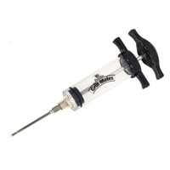
- Marinade Injector: The robust marinade injector makes it easy to plunge basting liquids strait into your favorite cuts of meat. Fill with a favorite McCormick® Grill Mates® marinade, from Smoky Applewood to Brown Sugar Bourbon.

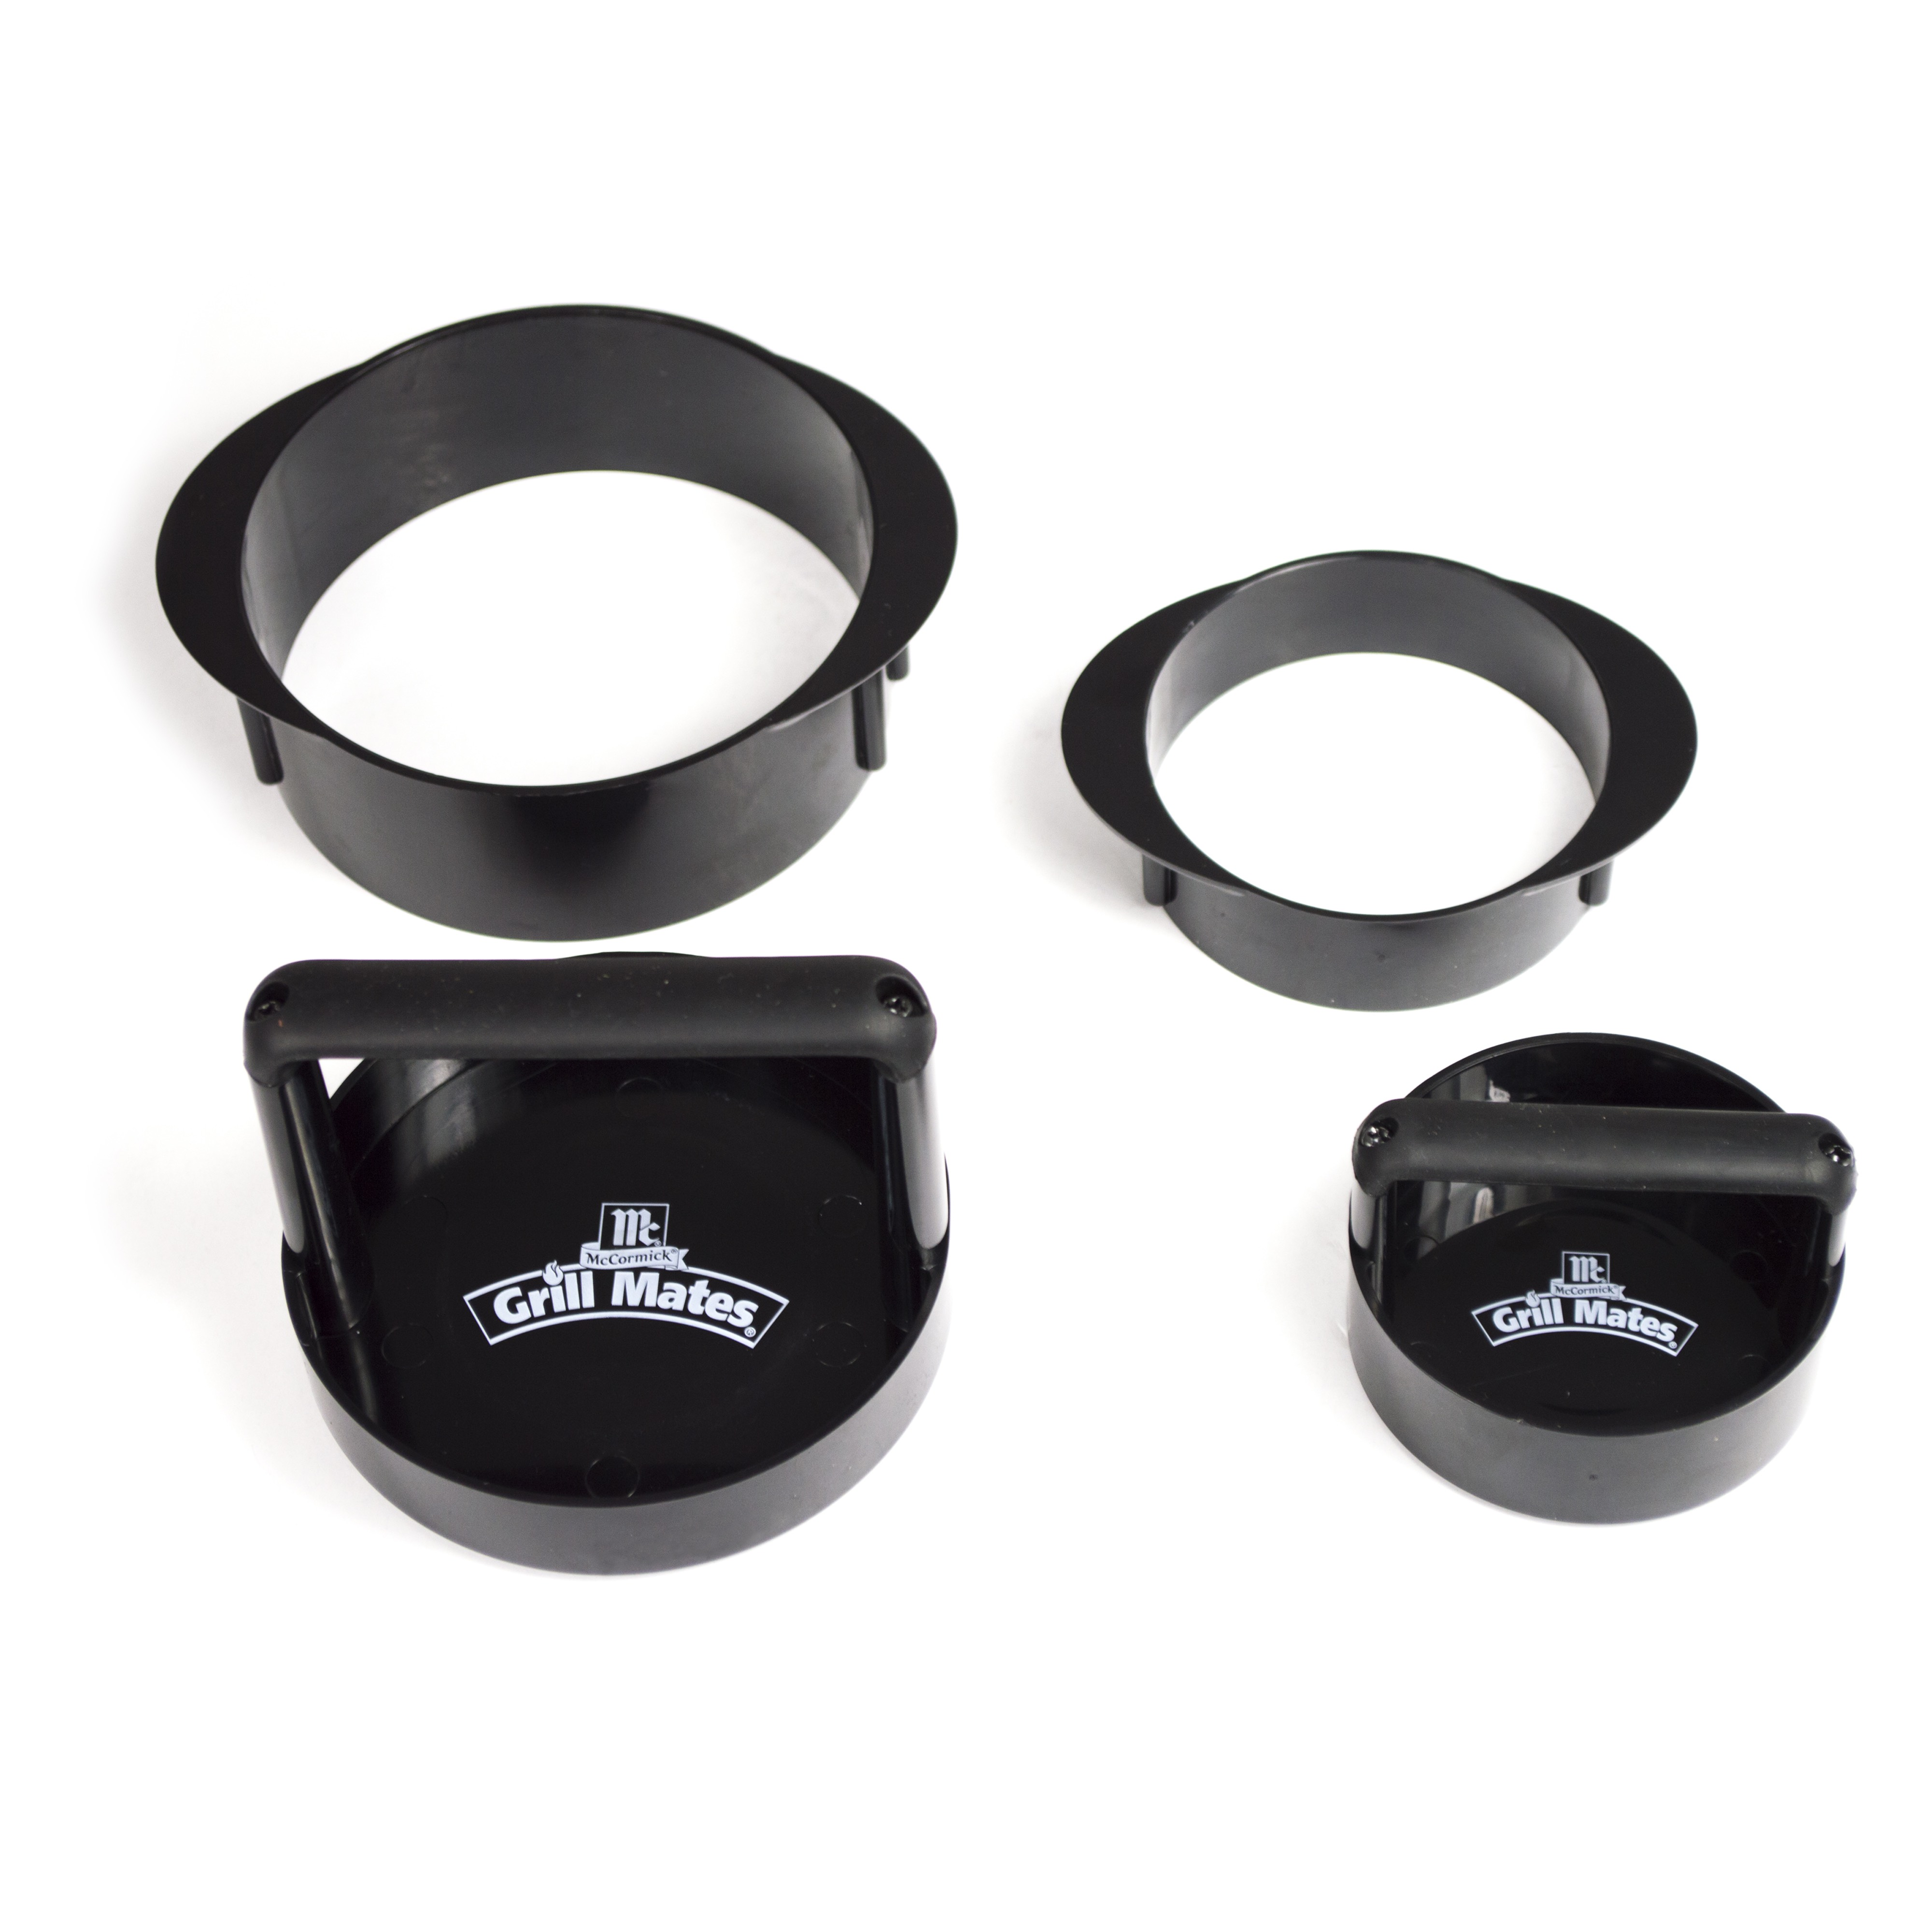
- 3-in-1 Burger Press: Create burgers, sliders, or stuffed burgers with one tool. The large press and ring are perfect for a classic hamburger, the small press can be used bite-sized sliders, or use them together to create a burger stuffed with your favorite toppings!
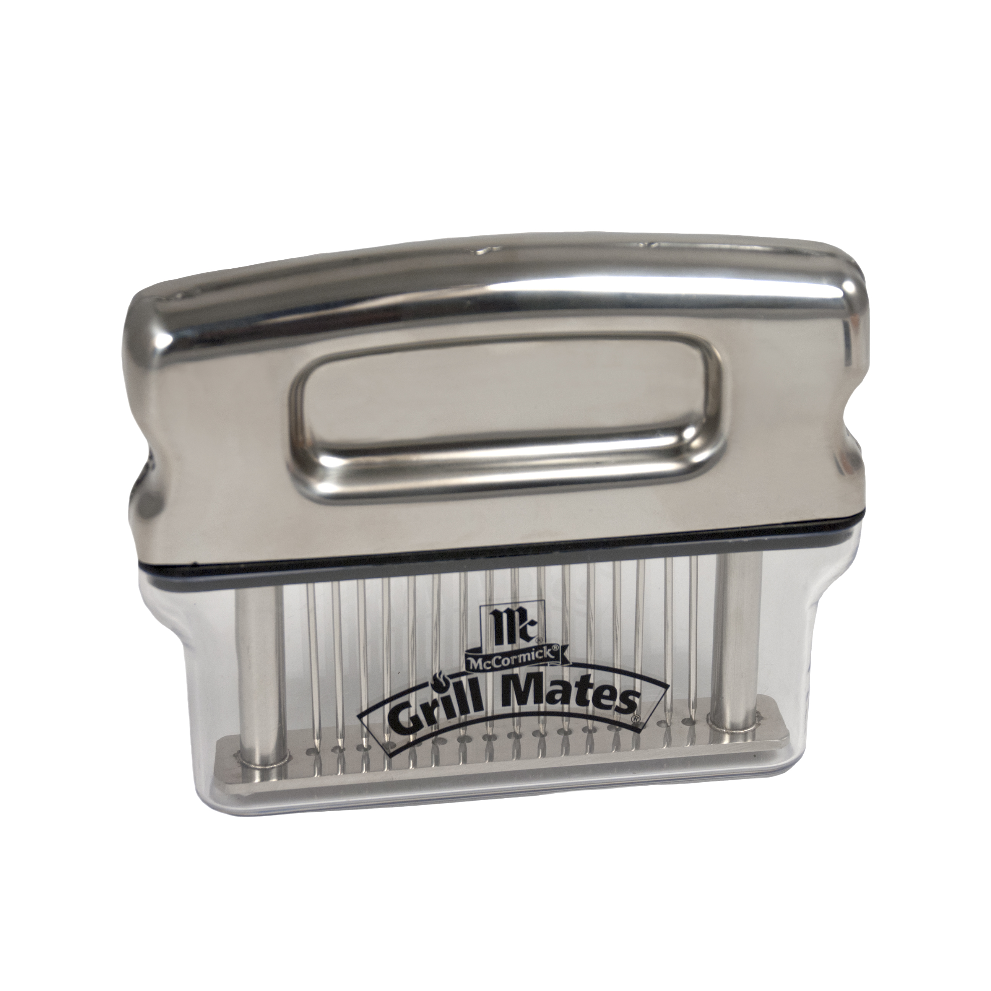
- Marinade Turbocharger: Stainless steel needles tenderize meat while imparting the flavor of your favorite McCormick® Grill Mates® marinade.

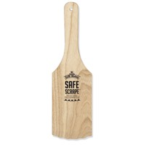
- Safe Scrape Non-Bristle Grill Cleaning Tool: This wooden scraping paddle removes debris from grill grates, while the heat and pressure from cleaning slowly shapes the paddle to fit the grill perfectly.

“This is a great opportunity to pair our expertise in grilling accessories with the recognition and loyalty that customers have for McCormick® Grill Mates®,” The Companion Group’s CEO Chuck Adams said. “We could not be more thrilled.”

# # #

Founded in the Bay Area in 1984, The Companion Group develops and markets an array of brands in the outdoor and indoor living categories, including Charcoal Companion®, Steven Raichlen Best of Barbecue™, pizzacraft®, and Not In My Backyard™. In 2014 The Companion Group evolved into an employee stock ownership plan (ESOP) and continues to thrive on a commitment to creative and innovative design, unique licensing-partnerships, superior communication and service, and well-developed retail solutions for an ever-changing marketplace. For more information, visit www.companion-group.com.

